WEEKLY FINDINGS REPORT
ARP Capture & Analysis
Weekly Cybersecurity Tools Learning — tcpdump Practical
Date | 3 September 2026
Analyst | Emmanuel Aidoo
Practical | ARP Request/Reply Capture
Tool(s) Used | tcpdump, ping
Environment | Kali Linux, interface eth0

1. Objective
Capture ARP (Address Resolution Protocol) traffic on the local network using tcpdump, and interpret how a device resolves an IP address to a MAC address before it can actually send traffic to it.

2. Commands / Steps Taken

Terminal 1 — Capture
sudo tcpdump -i eth0 -nn -e arp

-nn keeps addresses numeric; -e adds the Ethernet header to each line, which is what exposes the MAC addresses directly in the output; arp filters to ARP traffic only.

Terminal 2 — Generating traffic
ping -c 2 192.168.1.0

3. Evidence
Figure | File | What It Shows
Fig. 1 | ARP_Capture.png | Side-by-side capture: tcpdump ARP output (left) and the ping attempt that triggered it (right).
Figure 1 — ARP request/reply capture
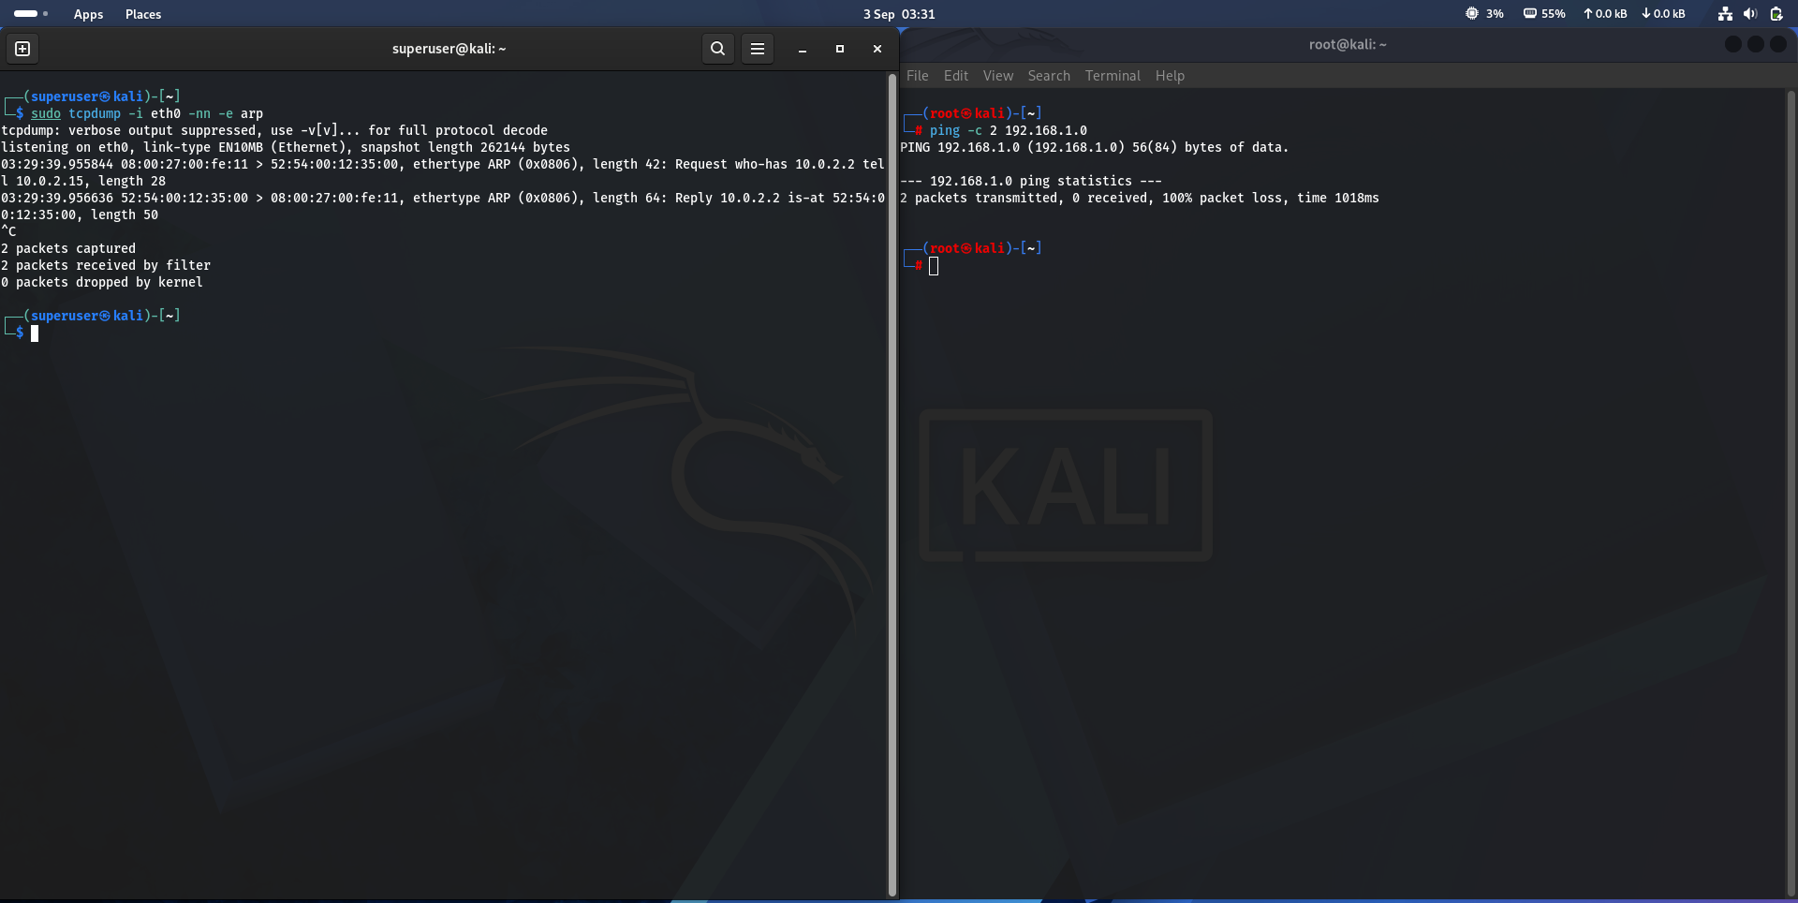

4. Findings / Analysis
The capture shows exactly one ARP request/reply pair:
Request who-has 10.0.2.2 tell 10.0.2.15, length 28
Reply 10.0.2.2 is-at 52:54:00:12:35:00, length 50

- Request: 10.0.2.15 (MAC 08:00:27:00:fe:11) broadcasts “who has 10.0.2.2?” — it needs that device's MAC address before it can send it any traffic.
- Reply: 10.0.2.2 (MAC 52:54:00:12:35:00) answers directly, confirming its own MAC address.
- -e: shows the source/destination MAC addresses on every line — without it, ARP's own request/reply content is still visible, but the surrounding Ethernet-frame addressing is not.

Why the ARP target doesn't match the ping target
The ping in Terminal 2 was aimed at 192.168.1.0, but the ARP request resolved 10.0.2.2 instead — not a mismatch, but expected behavior. 192.168.1.0 is outside the local 10.0.2.0/24 subnet, so the operating system routes it through the default gateway rather than trying to reach it directly. Before it can hand that packet off, it first has to resolve the gateway's own MAC address — which is exactly what this ARP exchange is doing. 10.0.2.2 is the default gateway address in this environment (the typical default for a VirtualBox/QEMU NAT network), which is consistent with the MAC vendor prefixes seen in the capture: 08:00:27 (VirtualBox) and 52:54:00 (QEMU/KVM).
The ping itself then failed with 100% packet loss. This is unrelated to ARP — 192.168.1.0 is not a valid host address in a standard /24 network (it's the network address itself, with no host bits set), so it was never going to get a reply regardless of whether the gateway's MAC was resolved correctly.

5. Conclusion
ARP resolution itself succeeded — the gateway answered immediately, confirming Layer 2 connectivity is healthy. The subsequent ping failure was a separate, higher-layer issue (an invalid destination address), not a sign that anything was wrong with the network's ARP/switching layer. This is a useful illustration of why a failure needs to be diagnosed at the correct layer: ARP succeeding does not guarantee the request built on top of it will succeed too.

6. Lessons Learned / Next Steps
- ARP requests happen automatically as part of routing a packet, even when the packet's ultimate destination turns out to be invalid or unreachable — the device still has to resolve its next hop first.
- Read “who-has X tell Y” as a request and “X is-at MAC” as the matching reply — the same subject-verb pattern every time.
- The -e flag is the one to reach for whenever MAC addresses specifically are relevant to an investigation — not part of tcpdump's default output.
- Next: capture ARP during a ping to a genuinely reachable local host, to compare against this unreachable-destination case.

